Glucose

<https://www.genome.jp/dbget-bin/www_bfind_sub?mode=bfind&max_hit=1000&dbkey=kegg&keywords=Glucose>

KEGG MODULE

M00001

Glycolysis (Embden-Meyerhof pathway), glucose => pyruvate

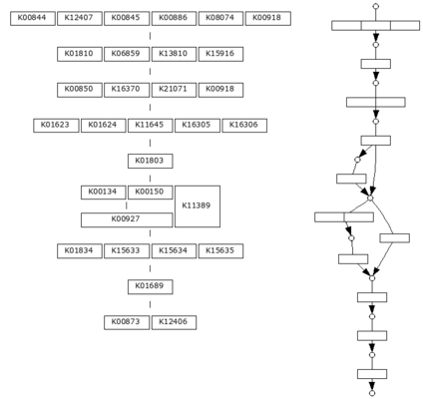

KEGG ORTHOLOGY

K00012

UGDH, ugd; UDPglucose 6-dehydrogenase [EC:1.1.1.22]

KEGG GENES

[KEGG GENES (6187)](https://www.genome.jp/dbget-bin/get_linkdb?-t+genes+ko:K00012)

KEGG REACTION

R00010

alpha,alpha-trehalose glucohydrolase; alpha,alpha-Trehalose + H2O <=> 2 D-Glucose

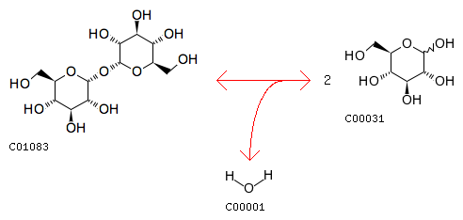

KEGG ENZYME

1.1.1.22

UDP-glucose 6-dehydrogenase; UDP-glucose dehydrogenase; uridine diphosphoglucose dehydrogenase; UDPG dehydrogenase; UDPG:NAD oxidoreductase; UDP-alpha-D-glucose:NAD oxidoreductase; UDP-glucose:NAD+ oxidoreductase; uridine diphosphate glucose dehydro • • •

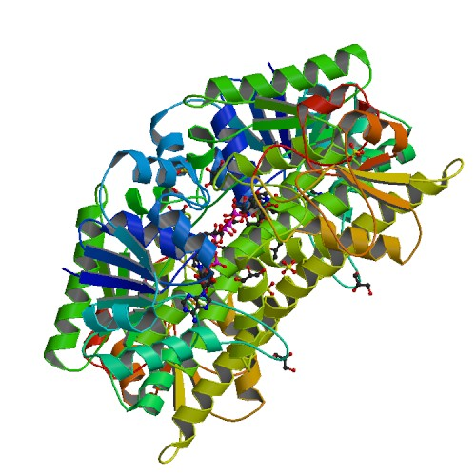

KEGG NETWORK

N00816

Transport of glucose 6-phosphate

|  |  |  |  |
| --- | --- | --- | --- |
| **Entry** | |  |  | | --- | --- | | N00816                      Network |  | |
| **Name** | Transport of glucose 6-phosphate |
| **Definition** | Glc-6P -- SLC37A4 -> Glc-6P(ER) |
| **Expanded** | C00092 -- 2542 -> C00092 |
| **Class** | [nt06017](https://www.genome.jp/kegg-bin/show_network?nt06017+N00816) Glycogen metabolism |
| **Type** | Reference |
| **Gene** | |  |  | | --- | --- | | [2542](https://www.genome.jp/dbget-bin/www_bget?hsa:2542) | SLC37A4; solute carrier family 37 member 4 | |
| **Metabolite** | |  |  | | --- | --- | | [C00092](https://www.genome.jp/dbget-bin/www_bget?cpd:C00092) | D-Glucose 6-phosphate | |

KEGG DISEASE

H00836

GLUT1 deficiency syndrome; Glucose transport defect of the blood-brain barrier

GLUT1 deficiency syndrome (GLUT1DS) is an autosomal dominant or recessive inborn error of glucose transport across the blood-brain barrier. The majority of patients carry mutations in the SLC2A1 gene encoding the GLUT1 transporter. Defects in the GLUT1 result in low cerebrospinal fluid (CSF) glucose levels termed hypoglycorrhachia. Affected individuals present with mental retardation and learning disabilities; also common are ataxia, dystonia, seizures, and acquired microcephaly.

H01261

Congenital glucose-galactose malabsorption

Glucose-galactose malabsorption (GGM) is an autosomal recessive disorder that is due to mutations in the gene coding for the sodium-glucose cotransporter (SGLT1/SLC5A1). GGM is characterized by neonatal onset of watery and acidic diarrhea, which becomes fatal within a few weeks unless glucose and galactose containing nutrients are removed from the diet.

H01375

Glucose 6-phosphate dehydrogenase deficiency

Glucose-6-phosphate dehydrogenase (G6PD) deficiency is an X-linked, hereditary disorder due to mutations in the G6PD gene, resulting in protein variants with different levels of enzyme activity, that are associated with a wide range of biochemical and clinical phenotypes. G6PD deficiency is the most common enzymatic disorder in humans. It is estimated that about 400 million people are affected by this deficiency. More than 400 biochemical variants of G6PD deficiency have since been defined, and grouped into five classes based on enzyme activity and clinical manifestations. The most common clinical manifestations are neonatal jaundice and acute haemolytic anaemia, which in most patients is triggered by an exogenous agent. A G6PD-deficient patient lacks the ability to protect red blood cells against oxidative stresses from certain drugs, infections, metabolic conditions, and ingestion of fava beans.

H01923

Microcephaly, short stature, and impaired glucose metabolism

Microcephaly, short stature, and impaired glucose metabolism (MSSGM) is a new syndrome of young onset diabetes, short stature and microcephaly with intellectual disability. The causal nonsense mutation in tRNA methyltransferase gene TRMT10A has been identified. TRMT10A is ubiquitously expressed but enriched in brain and pancreatic islets, consistent with the tissues affected in this syndrome. It has also been reported that mutation in the eukaryotic translation initiation factor 2 alpha (eIF2a) phosphatase gene, PPP1R15B, is associated with these symptoms.

KEGG DRUG

D00009

Glucose (JP17); Purified glucose (JP17); D-Glucose

